SQL Server on Docker Install Log

Environment Discussion
I’m installing SQL Server 2025 using a Docker image. The target machine is a Lenovo ThinkPad T480 (Intel i7 chip, 16GB RAM) running Omarchy Linux (consistently upgraded to latest version). I’ll ssh into the ThinkPad from my Mac Studio to allow me to use the screenshot capabilities of the Mac. This has the benefit of also proving connectivity as it will be used. Eventually Tableau will be installed on the Mac and connected to SQL Server on the ThinkPad. All machines involved are connected to a Tailscale network, which simplifies connectivity.

Installation Outline
Networking is setup and validated – ssh works. I’ll probably need to open a firewall hole for port 1433 (SQL Server default). Docker is already installed on Omarchy (I believe that it’s part of the default package).
Installation will include:
- Kick off Docker to download the image and create a container
- Open required networking port
- Install sqlcmd to prove the database works
- Validate from Mac

Installation Steps
- Connect to the SQL Server host. ssh omarchy
- Validate Docker is installed and of adequate version. Get network details.
docker ps -a
docker volume ls
tailscale ip -4
hostname
docker version

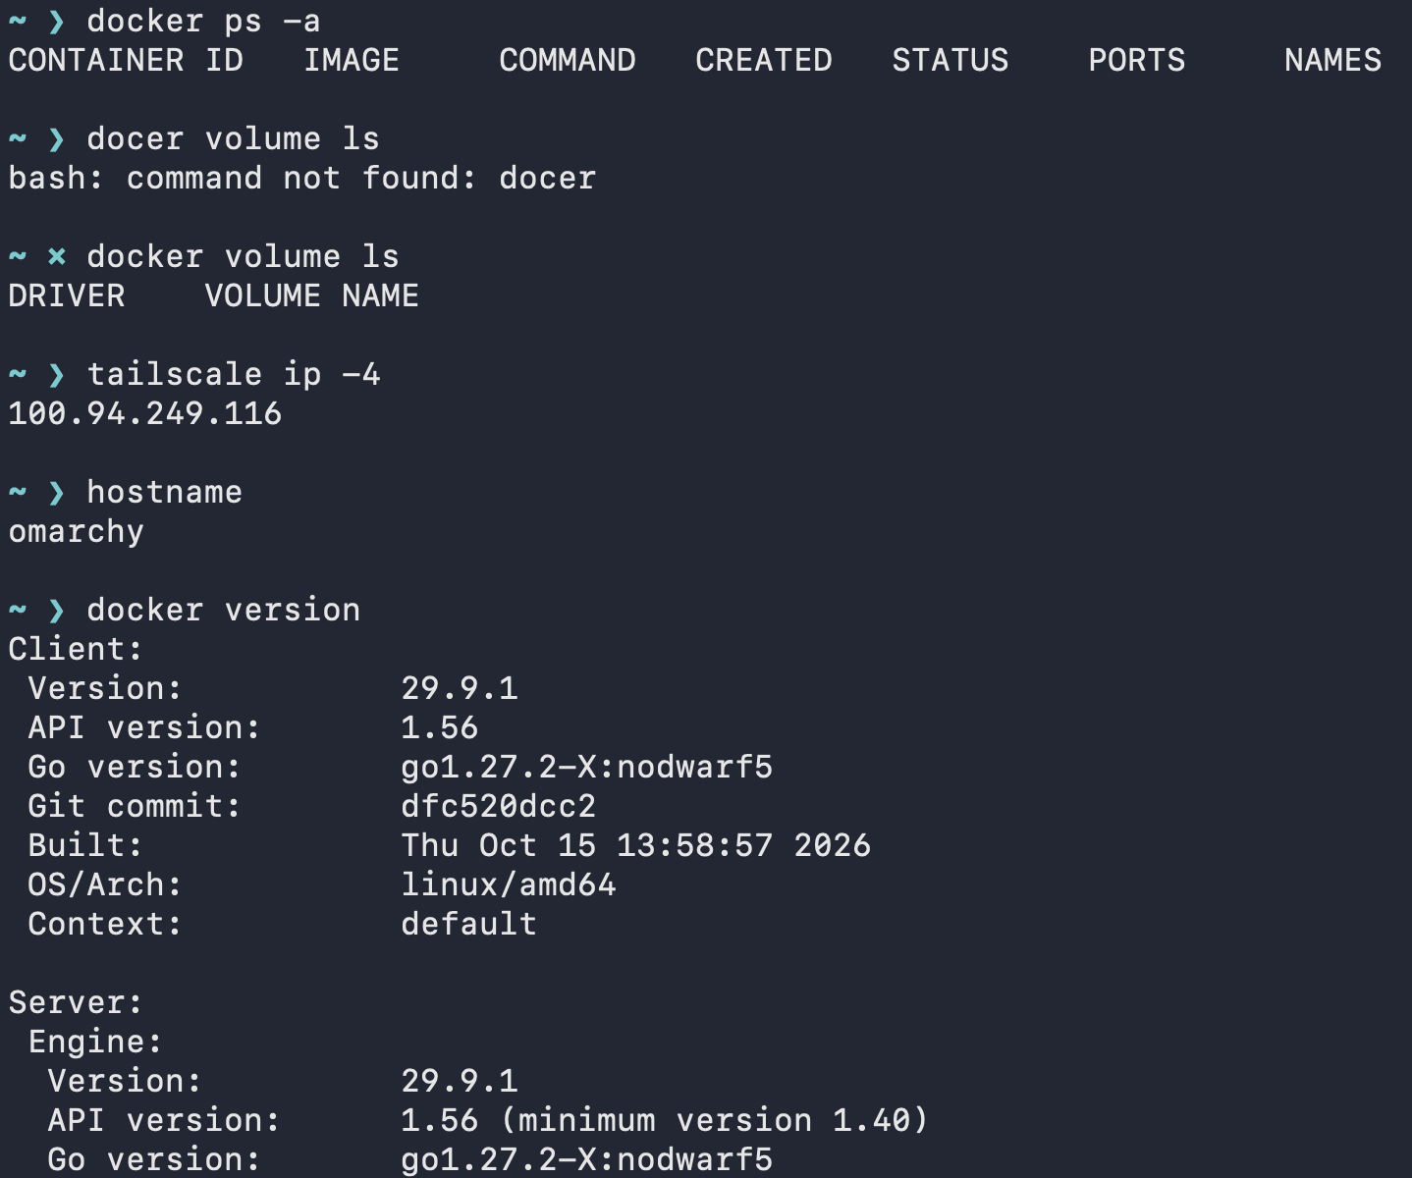

- Set a SQL Server sa password.
read -rsp 'SA password: ' pw; echo
printf 'ACCEPT_EULA=Y\nMSSQL_SA_PASSWORD=%s\n' "$pw" | sudo sh -c 'umask 077; cat > /root/mssql1.env'
unset pw
sudo ls -l /root/mssql1.env

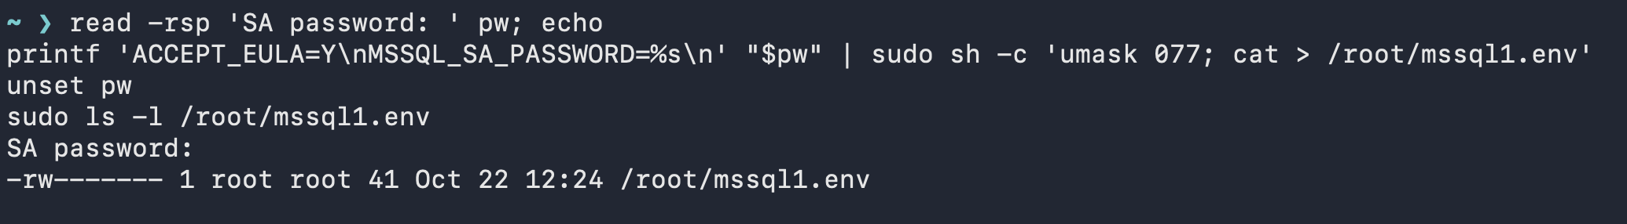

- Pull image and get container set up.
docker volume create mssql1data
sudo docker run --env-file /root/mssql1.env \
-p 100.94.249.116:1433:1433 \
--name mssql1 --hostname mssql1 \
-v mssql1data:/var/opt/mssql -d \
mcr.microsoft.com/mssql/server:2025-latest
sudo shred -u /root/mssql1.env

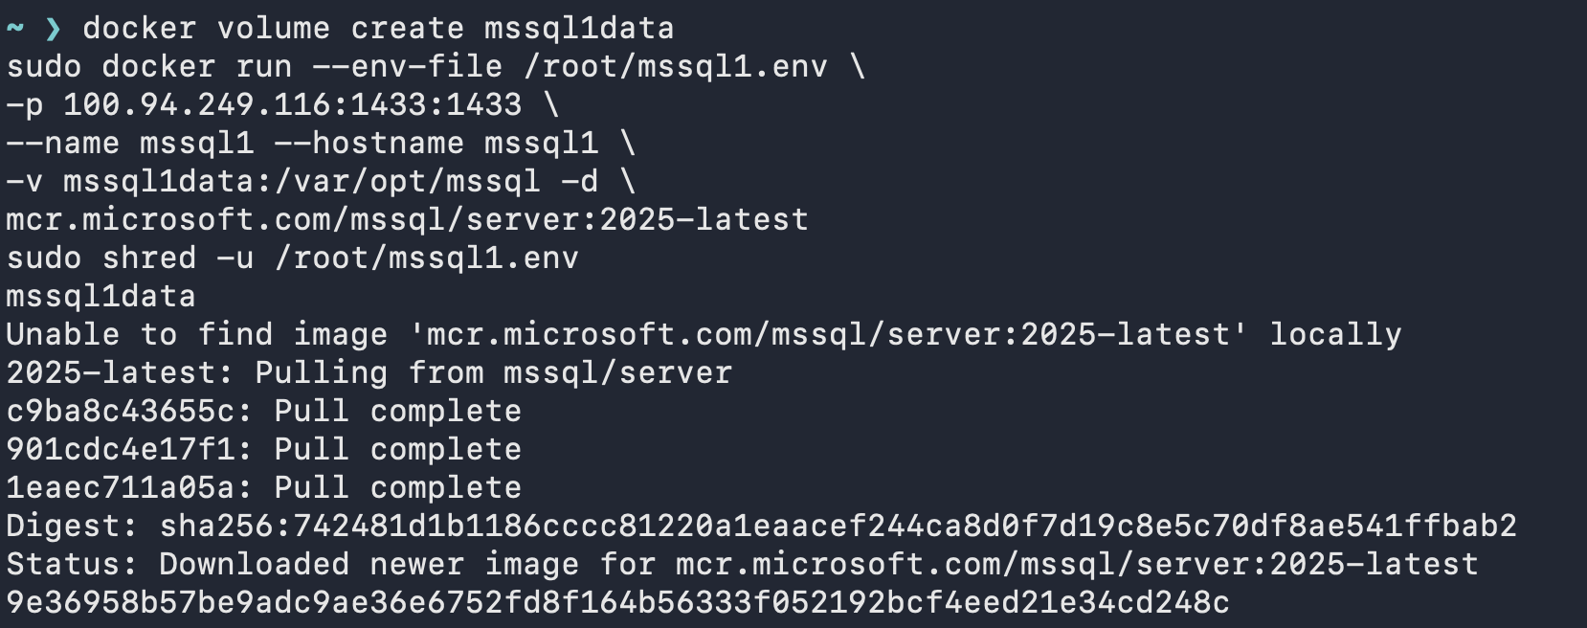

- Check if SQL Server container is running.
docker ps

- Using AI I created a handy script to start the SQL Server container if it’s not already running and validate. Available here.
- Install sqlcmd on the Mac
brew install sqlcmd
- Test connecting to SQL Server
sqlcmd -S omarchy -U sa -C -Q "select @@VERSION;"
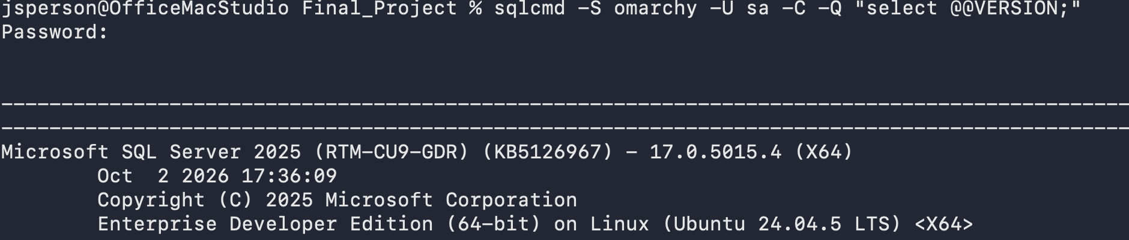
- Surprisingly the networking worked. I’ll open up a firewall port on the ThinkPad anyway just to make sure it doesn’t get in the way.
sudo ufw route allow in on tailscale0 proto tcp to any port 1433
sudo ufw status verbose

